HEMOPHILIA
Hemophilia A and B are genetic disorders of clotting factors VIII and IX, respectively. FVIII and FIX are either defective or made in insufficient amounts, resulting in impaired secondary hemostasis. The incidence of hemophilia A and B is about 1/5000 males worldwide and affects individuals of all races and socioeconomic groups.
Classical hemophilia, hemophilia A, is estimated to account for 85% of all cases. It is a deficiency or dysfunction of FXIII. Half of cases are caused by a variety of mutations in the gene coding for FXIII, resulting in a spectrum of disease presentation. The second half of cases are due to a “flip tip” inversion in the FVIII gene resulting in misreading of a non-coding region and a shortened gene product. All individuals with this inversion have severe disease.
Hemophilia B, also known as Christmas disease, is estimated to account for 15% of hemophilia cases and is caused by a deficiency or dysfunction of FIX.

Genetics
Both genes for FVIII and FIX are located on the X chromosome. The disease primarily affects males, but female carriers may be symptomatic. Daughters of affected males are obligate carriers. Genetic counseling is recommended for families and individuals affected by hemophilia.
One third of hemophilia A is due to spontaneous mutations and affected patients have no family history. However, all cases due to FVIII inversions are inherited for a mother carrier. The risk that a mother of an affected male is a carrier of hemophilia A is about 80%

Pathophysiology
Coagulation consists of two processes: primary and secondary hemostasis. Primary hemostasis involves the aggregation of platelets at an injury site. An initial platelet plug is established and subsequently replaced by a more stable fibrin clot through secondary hemostasis.
Secondary hemostasis involves the coagulation cascade: a sequence of reactions that ultimately leads to the formation of the stable fibrin clot. FVIII and FIX are both part of the intrinsic pathway of the coagulation cascade and are necessary to convert FX to FXa, the first step of the common pathway. A deficiency or defect in either FVIII or FIX decreases the activation FXa, impairing subsequent reactions necessary to create fibrin clots.

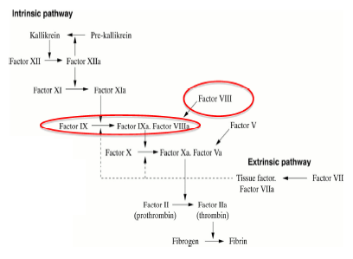
Clinical Presentations
There is a spectrum of disease severity among hemophiliacs. Severity is classified based on the amount of FVIII or FIX activity. The relative deficiency of activity is manifest by frequency and causes of bleeding episodes.
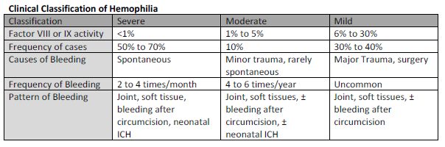
Hemophilia may present differently depending on the severity of disease. Therefore severe disease is likely to present early in life, while mild and moderate disease may present later.

Below is a list of possible presentations and complications of disease.
Intracranial hemorrhage (ICH): Occurs in 2 to 5% of individuals with hemophilia, can occur in 50% preterm infants with the disease. Half of cases arise spontaneously.
Leading cause of death among hemophiliacs.
Prolonged bleeding after circumcision occurs in 30% of affected neonates
Hematomas may occur following immunizations, Oral bleeding
Eruption of teeth may lead to anemia. Oral bleeding is not evident in infants because they swallow blood
Delayed bleeding may occur after dental procedures or tooth loss Soft Tissue Bleeding
Large intramuscular hematomas may occur. Muscles may become swollen, hard, and painful.
May present as acute abdomen, neuropathy, or compartment syndrome
Joint pain due to hemarthroses, can lead to hemophilic arthropathy. Patients often have a “target joint” that is site of recurrent bleeding episodes
Other presentations: Spontaneous hematuria, Menorrhagia

Prenatal Genetic testing should be offered to all known carriers of hemophilia gene
- Chorionic villus sampling is offered between 9 and 11 weeks gestation
- Amniocentesis is offered between 12 and 15 weeks gestation

Treatment
Management of hemophilia requires prevention and treatment of acute bleeding episodes. Acute bleeding episodes are treated with clotting factors. Patients often have a sense that they are bleeding. They may feel a trickling, warmth, or tingling sensation from blood accumulating in tissues.
Prophylaxis involves comprehensive care teams of physician specialists, dentists, genetic counselors, physical therapists, occupational therapists, and nurse coordinators.

SICKLE CELL ANEMIA
Sickle cell disease (SCD) is a serious group of conditions which are inherited (genetic). It affects the red blood cells in the blood. Sickle cell anaemia is the name of a specific form of SCD in which there are two sickle cell genes.

With SCD, the red blood cells have a tendency to go out of shape and become sickle-shaped (like a crescent moon) - instead of their normal disc shape.
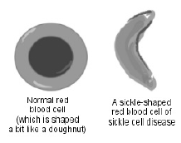
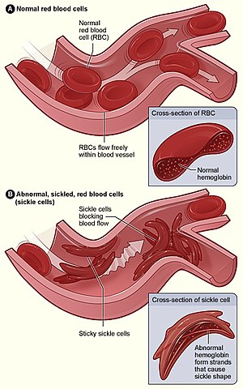

Sickle cell anemia is one of a group of disorders known as sickle cell disease. Sickle cell anemia is an inherited red blood cell disorder in which there aren't enough healthy red blood cells to carry oxygen throughout your body.
Normally, the flexible, round red blood cells move easily through blood vessels. In sickle cell anemia, the red blood are shaped like sickles or crescent moons. These rigid, sticky cells can get stuck in small blood vessels, which can slow or block blood flow and oxygen to parts of the body.
There's no cure for most people with sickle cell anemia. But treatments can relieve pain and help prevent complications associated with the disease.

Symptoms:
Signs and symptoms of sickle cell anemia usually appear around 5 months of age. They vary from person to person and change over time. Signs and symptoms can include:

Anemia. Sickle cells break apart easily and die, leaving you with too few red blood cells. Red blood cells usually live for about 120 days before they need to be replaced. But sickle cells usually die in 10 to 20 days, leaving a shortage of red blood cells (anemia).Without enough red blood cells, your body can't get enough oxygen, causing fatigue.

Episodes of pain. Periodic episodes of pain, called pain crises, are a major symptom of sickle cell anemia. Pain develops when sickle-shaped red blood cells block blood flow through tiny blood vessels to your chest, abdomen and joints. Pain can also occur in your bones.
The pain varies in intensity and can last for a few hours to a few weeks. Some people have only a few pain crises a year. Others have a dozen or more pain crises a year. A severe pain crisis requires a hospital stay.
Some adolescents and adults with sickle cell anemia also have chronic pain, which can result from bone and joint damage, ulcers, and other causes.
Swelling of hands and feet. The swelling is caused by sickle-shaped red blood cells blocking blood flow to the hands and feet.
Frequent infections. Sickle cells can damage your spleen, leaving you more vulnerable to infections. Doctors commonly give infants and children with sickle cell anemia vaccinations and antibiotics to prevent potentially life-threatening infections, such as pneumonia.
Delayed growth or puberty. Red blood cells provide your body with the oxygen and nutrients needed for growth. A shortage of healthy red blood cells can slow growth in infants and children and delay puberty in teenagers.
Vision problems. Tiny blood vessels that supply your eyes can become plugged with sickle cells. This can damage the retina — the portion of the eye that processes visual images — and lead to vision problems.

This condition is inherited in an autosomal recessive pattern, which means both copies of the gene in each cell have mutations. The parents of an individual with an autosomal recessive condition each carry one copy of the mutated gene, but they typically do not show signs and symptoms of the condition.

Genetics
Normally, humans have haemoglobin A, which consists of two alpha and two beta chains, haemoglobin A2, which consists of two alpha and two delta chains, and haemoglobin F, consisting of two alpha and two gamma chains in their bodies. Of these three types, haemoglobin F dominates until about 6 weeks of age. Afterwards, haemoglobin A dominates throughout life. In people diagnosed with sickle cell disease, at least one of the β-globin subunits in haemoglobin A is replaced with what is known as haemoglobin S. In sickle cell anaemia, a common form of sickle cell disease, haemoglobin S replaces both β-globin subunits in the haemoglobin.
The gene defect is a single nucleotide mutation (single-nucleotide polymorphism – SNP) (GAG codon changing to GTG) of the β-globin gene, which results in glutamic acid being substituted by valine (V/Val) at position 6, on the p arm of chromosome 11.
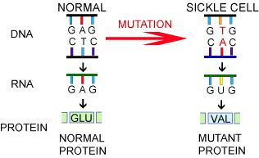
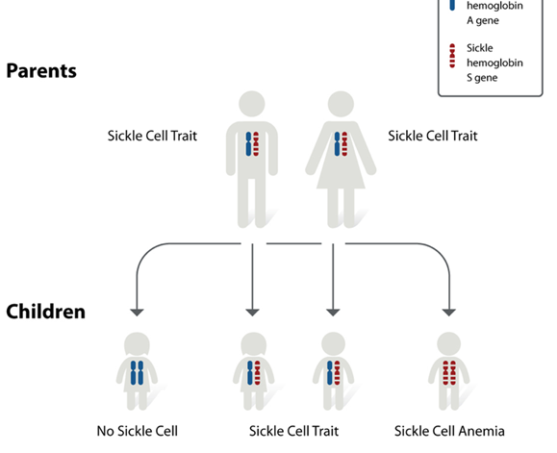

Other Complications
Sickle cell anemia can lead to a host of complications, including:
Stroke. Sickle cells can block blood flow to an area of brain, leading to seizures, weakness or numbness of your arms and legs, sudden speech difficulties, and loss of consciousness.
Acute chest syndrome. A lung infection resulting in chest pain, fever and difficulty breathing. It might require emergency medical treatment.
Pulmonary hypertension. People with sickle cell anemia can develop high blood pressure in their lungs leading to shortness of breath and fatigue .
Organ damage. Due to decrease in blood flow, lack of oxygen-rich blood can damage nerves and organs, including your kidneys, liver and spleen, and can be fatal.
It can lead to Blindness, Leg ulcers, Gallstones, Pregnancy complications etc

Prevention

Genetic counseling

Preventive measures

Reproductive options

THALASSEMIA
Thalassemias are a heterogeneous group of hereditary blood disorders characterized by faulty globin chain synthesis resulting in defective hemoglobin, which can lead to anemia. Based on the defective globin chain, they are classified as either alpha or beta subtypes.
Thalassemias are generally more frequent in areas where malaria is endemic; alpha thalassemias occur most commonly in patients of Asian or African origin, whereas beta thalassemias are predominant in patients of Mediterranean descent.
Beta thalassemia can be further divided into a heterozygous minor and a homozygous major variant. The minor variant features only a low risk of hemolysis; however, the major variant presents with severe anemia as early as infancy and often causes growth retardation.
The severity of alpha thalassemias varies as well, with significant anemia generally first arising with a deletion of three of the four alleles (HbH disease). Deletion of all four α-globin alleles (Hb Bart disease) is usually fatal in utero or shortly after birth. In all forms of thalassemia, insufficient erythropoiesis can lead to extramedullary hematopoiesis as well as bone marrow hyperplasia.
The latter frequently results in periosteal reactions that are observed as the classic "hair-on-end" sign on skull radiographs. Diagnosis is confirmed via electrophoresis or DNA analysis. If a patient with thalassemia requires transfusion therapy, it is important to consider the possible development of secondary iron overload, which should be treated with chelating agents (e.g., deferoxamine).

Cause: gene mutations
Beta thalassemia: usually due to point mutations in promoter sequences or splicing sites β-globin locus - short arm of chromosome 11
Alpha thalassemia: usually due to deletion of at least one out of the four existing alleles
Inheritance pattern: autosomal recessive

Pathophysiology
Normally, the majority of adult hemoglobin (HbA) is composed of four protein chains, two α and two β globin chains arranged into a heterotetramer. In thalassemia, patients have defects in either the α or β globin chain, causing production of abnormal red blood cells (In sickle-cell disease, the mutation is specific to β globin).
The thalassemias are classified according to which chain of the hemoglobin molecule is affected. In α-thalassemias, production of the α globin chain is affected, while in β-thalassemia, production of the β globin chain is affected.
The β globin chains are encoded by a single gene on chromosome 11; α globin chains are encoded by two closely linked genes on chromosome 16. Thus, in a normal person with two copies of each chromosome, two loci encode the β chain, and four loci encode the α chain. Deletion of one of the α loci has a high prevalence in people of African or Asian descent, making them more likely to develop α-thalassemia. β-Thalassemias are not only common in Africans, but also in Greeks and Italians.

Inheritance:

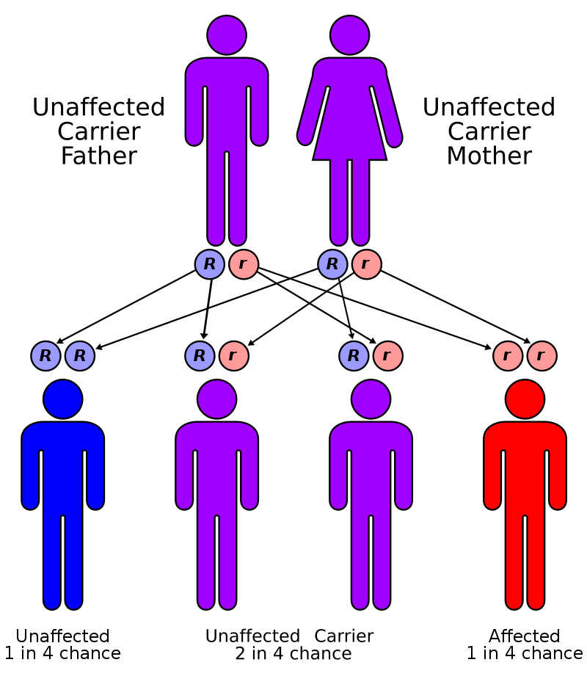

Silent carrier: asymptomatic
Alpha thalassemia trait: mild hemolytic anemia with normal RBC and RDW( Red blood cell distribution width)
Hemoglobin H disease
Jaundice and anemia at birth
Chronic hemolytic anemia which may require transfusions → possibly secondary iron overload due to hemolysis, transfusion, or both (→ secondary hemochromatosis)
Hepatosplenomegaly
Skeletal deformities (less common)
Incompatible with life (death in utero or shortly after birth)

Laboratory tests
Blood sample
Microcytic hypochromic anemia: Iron deficiency anemia (IDA) usually presents with a low RBC count and a high RDW, whereas patients with thalassemia minor or thalassemia trait usually have a normal RDW and a higher RBC, hemoglobin is less than 10 g/dL.
Signs of hemolysis (↓ haptoglobin, ↑ LDH, ↑ indirect bilirubin, ↑ reticulocytes)
Blood smear: target cells; teardrop cells
Bone marrow biopsy: reactive hyperplasia
Confirmatory tests
Hb-electrophoresis
Alpha thalassemia can usually only be detected if ≥ 3 alleles are defective.
Abnormal pattern depends on the exact subtype (see hemoglobin variants).
DNA analysis: to test for alpha thalassemia minor and minima (< 3 alleles defective)

Hypoglycemia & Hyperglycemia
Hyperglycemia occurs when blood sugar levels are too high. People develop hyperglycemia if their diabetes is not treated properly.
Hypoglycemia sets in when blood sugar levels are too low. This is usually a side effect of treatment with blood-sugar-lowering medication.
Diabetes is a metabolic disease with far-reaching health effects. In type 1 diabetes, the body only produces very little insulin, or none at all. In type 2 diabetes, not enough insulin is released into the bloodstream, or the insulin cannot be used properly.
We need insulin to live. Without it, sugar (glucose) builds up in the blood because it cannot be taken out and used by the body. Very high blood sugar, known as hyperglycemia, leads to a number of symptoms. If blood sugar levels are too low, it is called hypoglycemia

Slight fluctuations in blood sugar levels are completely normal and also happen on a daily basis in people who do not have diabetes. Between around 60 and 140 milligrams of sugar per deciliter of blood (mg/dL) is considered to be healthy. This is equivalent to blood sugar concentrations
between 3.3 and 7.8 mmol/L. “Millimole per liter” (mmol/L) is the international unit for measuring blood sugar. It indicates the concentration of a certain substance per liter.

If type 1 diabetes is left untreated, people’s blood sugar levels can get very high, sometimes exceeding 27.8 mmol/L (500 mg/dL). Blood sugar concentrations below 3.3 mmol/L (60 mg/dL) are considered to be too low. As you can see in the illustration below, there are no clear-cut borders between the normal range of blood sugar and high and low blood sugar.

Signs of Hyperglycemia:
Signs of very high blood sugar levels in type 1 diabetes may include the following:
Extreme thirst, drinking a lot and then urinating frequently as a result
Unintentionally losing a lot of weight within a few weeks
Noticeable loss of energy with muscle weakness, tiredness and generally feeling quite unwell
Nausea and stomach ache
Trouble seeing
Poor concentration
Frequent infections (cystitis, thrush)
Confusion and drowsiness, or even coma

Signs of Hypoglycemia
Low blood sugar is most common in people who use insulin or take certain tablets to reduce high blood sugar. This is because things like unplanned physical activity, eating meals later than usual, or drinking too much alcohol can cause blood sugar to drop very low.
Signs that your blood sugar is too low may include:
Racing pulse
Cold sweats
Pale face
Headache
Feeling incredibly hungry
Shivering, feeling weak in the knees
Feeling restless, nervous or anxious
Difficulty concentrating, confusion

Classification of Diabetes
The majority of cases of diabetes can be broadly classified into 2 categories: type 1 diabetes and type 2 diabetes, although some cases are difficult to classify. Gestational diabetes (GDM) refers to glucose intolerance with onset or first recognition during pregnancy
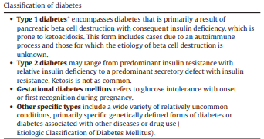
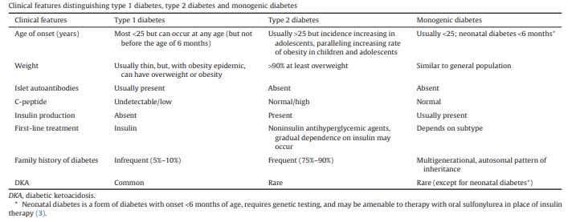
Diagnostic Tests for Diabetes
Diabetes may be diagnosed based on A1C criteria or plasma glucose criteria, either the fasting plasma glucose (FPG) or the 2-h plasma glucose (2-h PG) value after a 75-g oral glucose tolerance test (OGTT).
- Random blood sugar test. A blood sample will be taken at a random time. Regardless of when you last ate, a random blood sugar level of 200 milligrams per deciliter (mg/dL) — 11.1 millimoles per liter (mmol/L) — or higher suggests diabetes.
- Fasting blood sugar test. A blood sample will be taken after an overnight fast. A fasting blood sugar level less than 100 mg/dL (5.6 mmol/L) is normal. A fasting blood sugar level from 100 to 125 mg/dL (5.6 to 6.9 mmol/L) is considered prediabetes. If it's 126 mg/dL (7 mmol/L) or higher on two separate tests, you have diabetes.
- Oral glucose tolerance test. For this test, you fast overnight, and the fasting blood sugar level is measured. Then you drink a sugary liquid, and blood sugar levels are tested periodically for the next two hours.
A blood sugar level less than 140 mg/dL (7.8 mmol/L) is normal. A reading of more than 200 mg/dL (11.1 mmol/L) after two hours indicates diabetes. A reading between 140 and 199 mg/dL (7.8 mmol/L and 11.0 mmol/L) indicates prediabetes.

DIABETIC KETOACIDOSIS
Symptoms of DKA can appear quickly and may include:
Frequent urination
Extreme thirst
High blood sugar levels
High levels of ketones in the urine
Nausea or vomiting
Abdominal pain
Confusion
Fruity-smelling breath
A flushed face
Fatigue
Rapid beat

Diabetic ketoacidosis arises because of a lack of insulin in the body. The lack of insulin and corresponding elevation of glucagon leads to increased release of glucose by the liver (a process that is normally suppressed by insulin) from glycogen via glycogenolysis and also through gluconeogenesis. High glucose levels spill over into the urine, taking water and solutes (such as sodium and potassium) along with it in a process known as osmotic diuresis.^{[3]} This leads to polyuria, dehydration, and polydipsia. The absence of insulin also leads to the release of free fatty acids from adipose tissue (lipolysis), which are converted through a process called beta oxidation, again in the liver, into ketone bodies (acetoacetate and β-hydroxybutyrate). β-Hydroxybutyrate can serve as an energy source in the absence of insulin-mediated glucose delivery, and is a protective mechanism in case of starvation. The ketone bodies, however, have a low pKa and therefore turn the blood acidic (metabolic acidosis). The body initially buffers the change with the bicarbonate buffering system, but this system is quickly overwhelmed and other mechanisms must work to compensate for the acidosis. One such mechanism is hyperventilation to lower the blood carbon dioxide levels (a form of compensatory respiratory alkalosis). This hyperventilation, in its extreme form, may be observed as Kussmaul respiration.

ARTERIOSCLEROSIS
Arteriosclerosis occurs when the blood vessels that carry oxygen and nutrients from heart to the rest of your body (arteries) become thick and stiff — sometimes restricting blood flow to your organs and tissues. Healthy arteries are flexible and elastic, but over time, the walls in arteries can harden, a condition commonly called hardening of the arteries.
Atherosclerosis is a slow, progressive disease that may begin as early as childhood. Although the exact cause is unknown, atherosclerosis may start with damage or injury to the inner layer of an artery. The damage may be caused by:
High blood pressure
High cholesterol
High triglycerides, a type of fat (lipid) in your blood
Smoking and other sources of tobacco
Insulin resistance, obesity or diabetes
Inflammation from diseases, such as arthritis, lupus or infections, or inflammation of unknown cause
Once the inner wall of an artery is damaged, blood cells and other substances often clump at the injury site and build up in the inner lining of the artery.

Risk factors
Hardening of the arteries occurs over time. Besides aging, factors that increase the risk of atherosclerosis include:
High blood pressure
High cholesterol
Diabetes
Obesity
Smoking and other tobacco use
A family history of early heart disease
Lack of exercise
An unhealthy diet

Complications
The complications of atherosclerosis depend on which arteries are blocked. For example:
Coronary artery disease. When atherosclerosis narrows the arteries close to heart, you may develop coronary artery disease, which can cause chest pain (angina), a heart attack or heart failure.
Carotid artery disease. When atherosclerosis narrows the arteries close to your brain, you may develop carotid artery disease, which can cause a transient ischemic attack (TIA) or stroke.
Peripheral artery disease. When atherosclerosis narrows the arteries in your arms or legs, you may develop circulation problems in your arms and legs called peripheral artery disease. This can make you less sensitive to heat and cold, increasing your risk of burns or frostbite. In rare cases, poor circulation in your arms or legs can cause tissue death (gangrene).
Aneurysms. Atherosclerosis can also cause aneurysms, a serious complication that can occur anywhere in your body. An aneurysm is a bulge in the wall of your artery.
Most people with aneurysms have no symptoms. Pain and throbbing in the area of an aneurysm may occur and is a medical emergency.
If an aneurysm bursts, you may face life-threatening internal bleeding. Although this is usually a sudden, catastrophic event, a slow leak is possible. If a blood clot within an aneurysm dislodges, it may block an artery at some distant point.
Chronic kidney disease. Atherosclerosis can cause the arteries leading to your kidneys to narrow, preventing oxygenated blood from reaching them. Over time, this can affect your kidney function, keeping waste from exiting your body.

Prevention
The same healthy lifestyle changes recommended to treat atherosclerosis also help prevent it. These include:
Quitting smoking
Eating healthy foods
Exercising regularly
Maintaining a healthy weight

